***University of Missouri-Kansas City***

***Subject- Cloud Computing***

***Deployment of website hosting from google cloud, azure and Amazon web services***

***Submitted to:***

***Dr. Baek Young Choi (Cloud Computing Professor)***

***Submitted by:***

***MIHIR PITALE (16252203)***

***GOOGLE CLOUD PLATFORM***

1. The public cloud is accessed as follows-

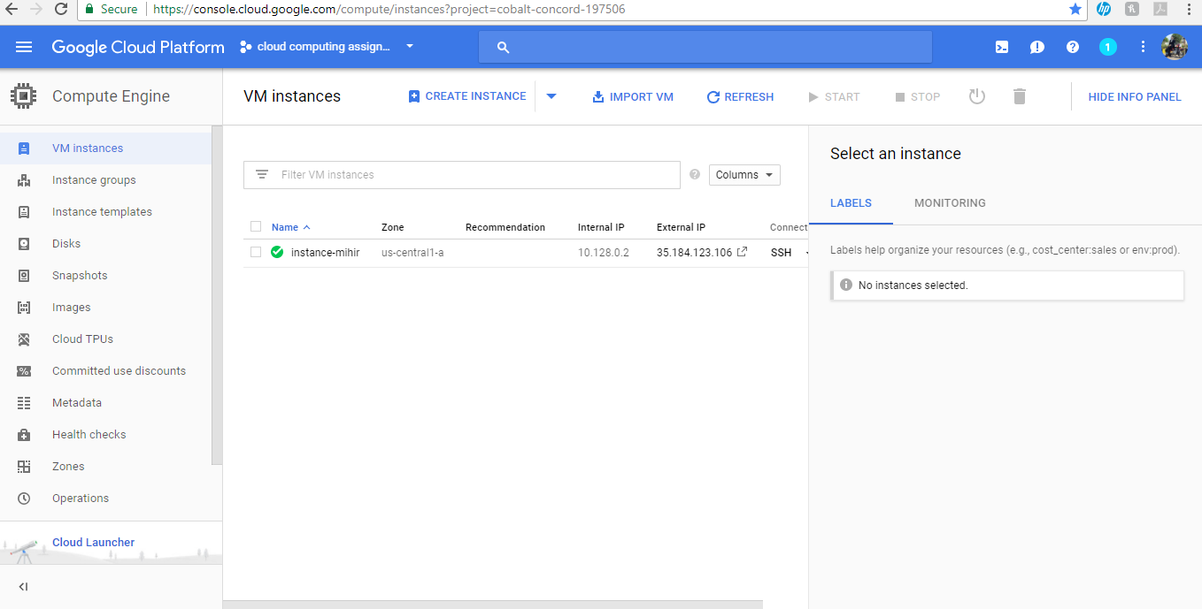

1. Deployment of service on Google cloud

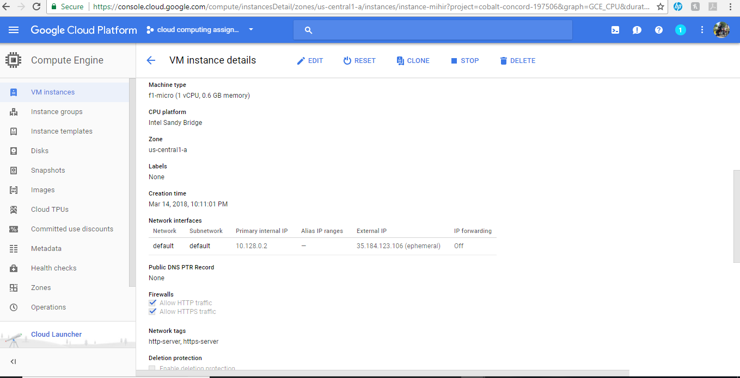

1. The output is as follows

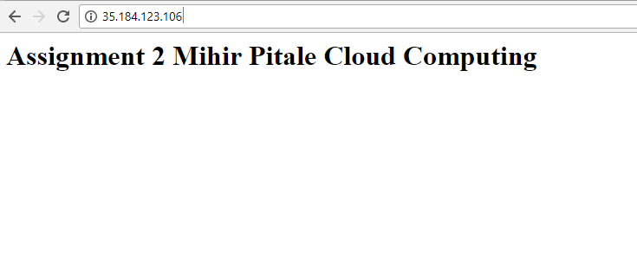

***AMAZON WEB SERVICES***

1. The public amazon cloud is accessed as follows-

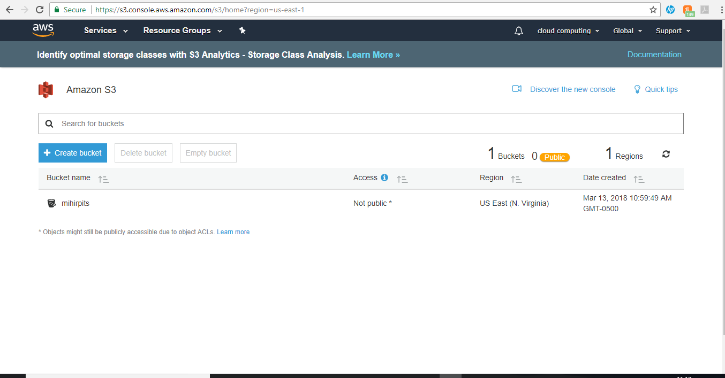

1. Deployment of AWS cloud as follows-

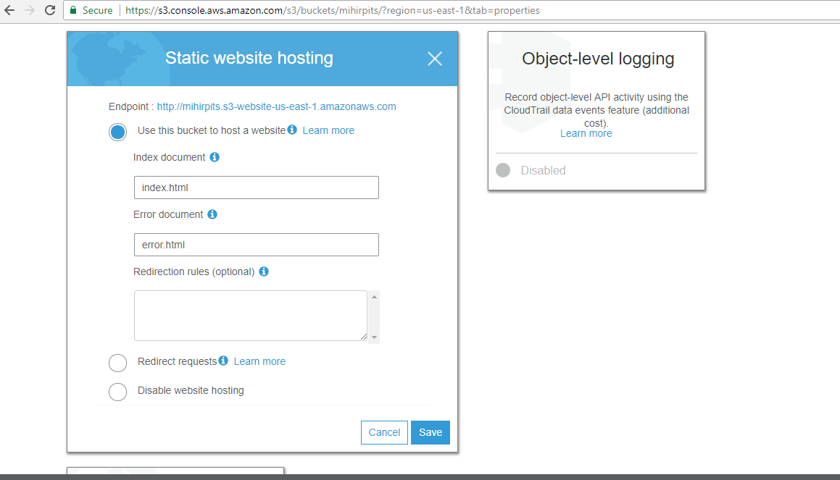

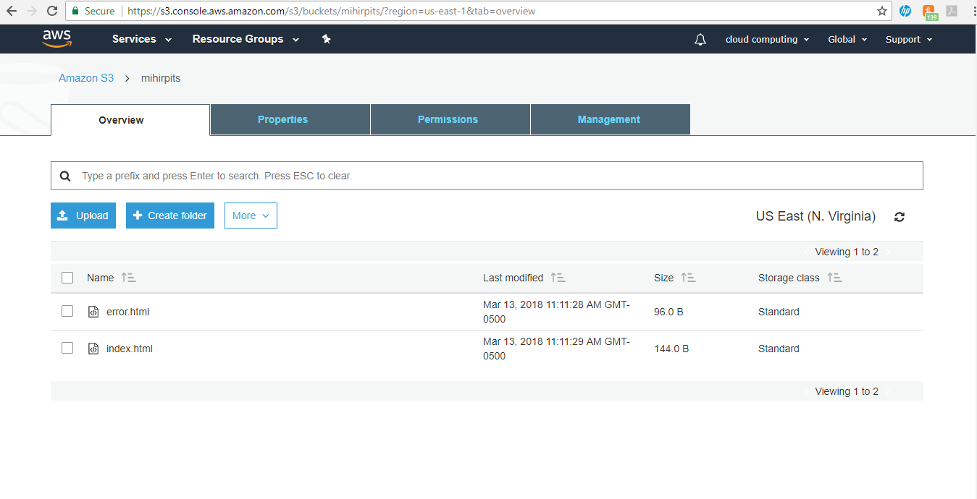

1. The output of AWS cloud is as follows-

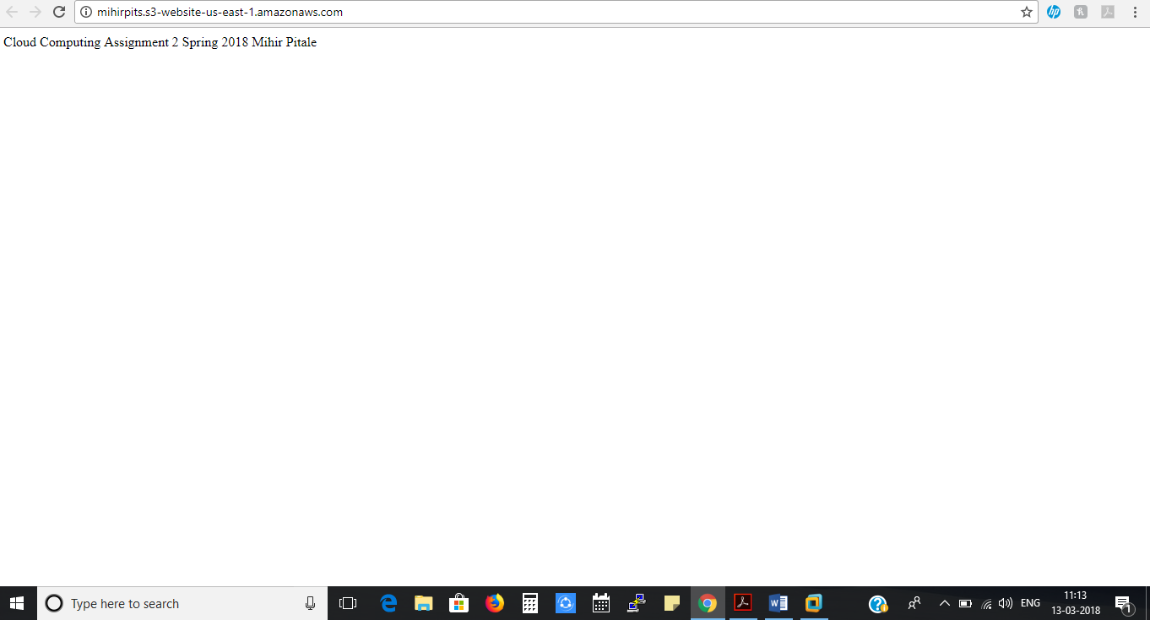

***AZURE CLOUD PLATFORM***

1. The public Azure cloud platform is accessed as follows-

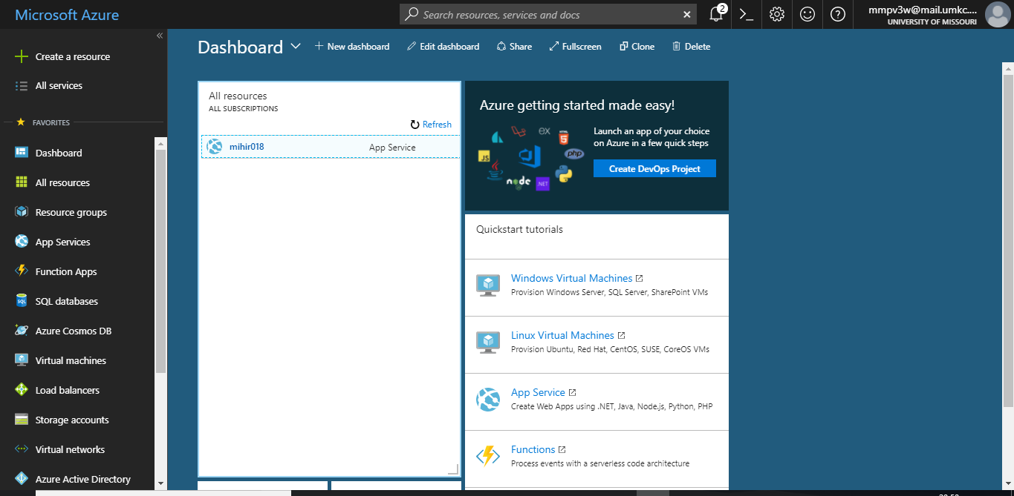

1. Deployment of Azure Cloud Platform web app is-

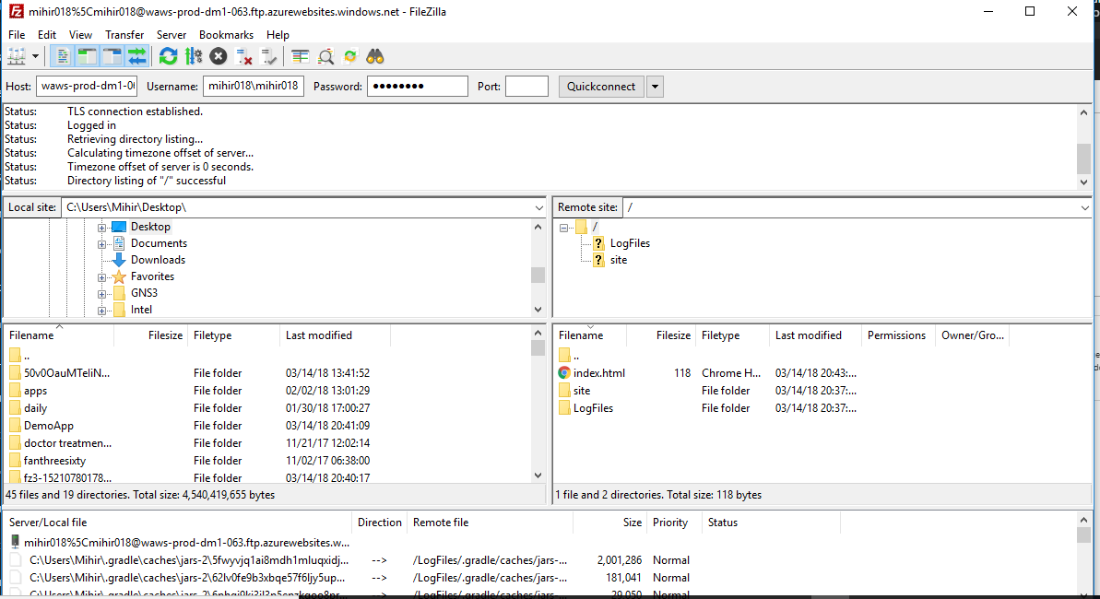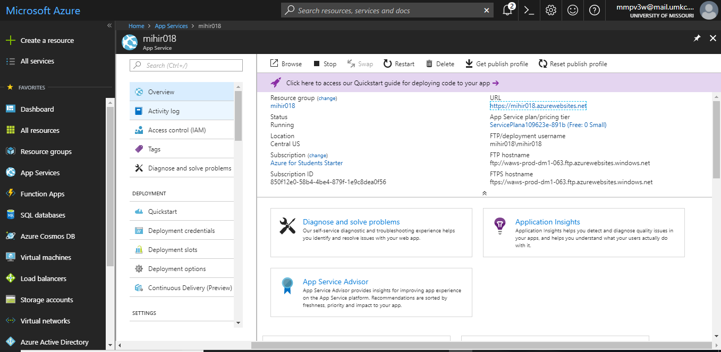

1. Output of Azure cloud platform is as follows-

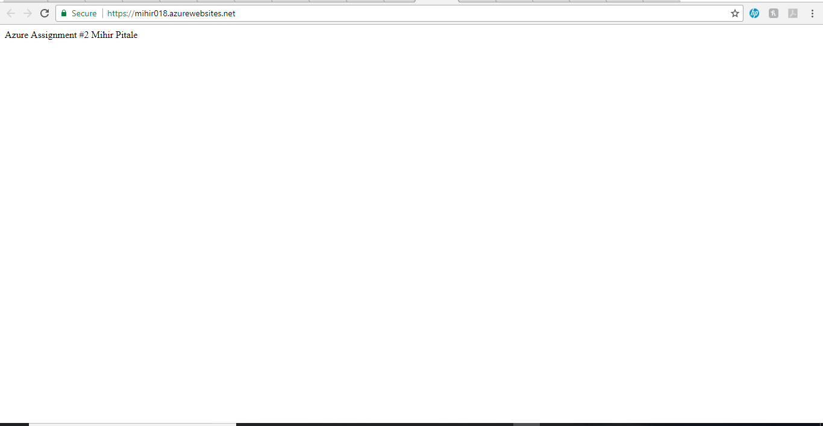

1. I successfully deployed static website on three different cloud platforms.

I found Google Cloud Platform to be more user friendly and deployable in fast paced environment

Aws do offer vast number of options and services for commercial users as well as professional users.

It has various types of storage, ram capacity as well as its famous quote “Pay as you go “is practically good fit for users to be clear and alert whenever deploying amazon web services.

Finally, Microsoft Azure was difficult to deploy at first because of complications in understanding the cloud interface at first.

Web app was deployed in Microsoft azure rather than creating buckets as of in Google and AWS platforms.

FTP client FileZilla was used to copy the html file to the web app hosted on Microsoft azure.

Amongst all the cloud, I found GENI to be a good fit for cloud deployment learning as it is a free platform available for students to deploy and have hands-on experience.

Cons- GENI has a limited deployment scope when compared to other clouds in terms of CPU, RAM, services available and ease to configure on a larger scale.

It was fun to deploy websites on all the clouds as far as website works!

GOOGLE CLOUD Platform link- 35.184.123.106

Amazon Web Services Link- <http://mihirpits.s3-website-us-east-1.amazonaws.com/>

Azure Cloud Platform Link- <https://mihir018.azurewebsites.net>

**x-x-x-x-x-x-x-x-x-x-x-x-x-x-xx-x-x-x-x-x-x-x-x**